Being an Inclusive Leader
Inclusive Leaders have been shown to have a positive impact on employee engagement, motivation, job satisfaction, creativity, collaboration and performance.
The opportunties to practice inclusive leadership are limitless. Everyday, in your workplace you will be prioritising and planning, making decisions, interacting with others and getting on with your work. Within all these simple acts are the openings to be inclusive. An ongoing process of inquiry and action.

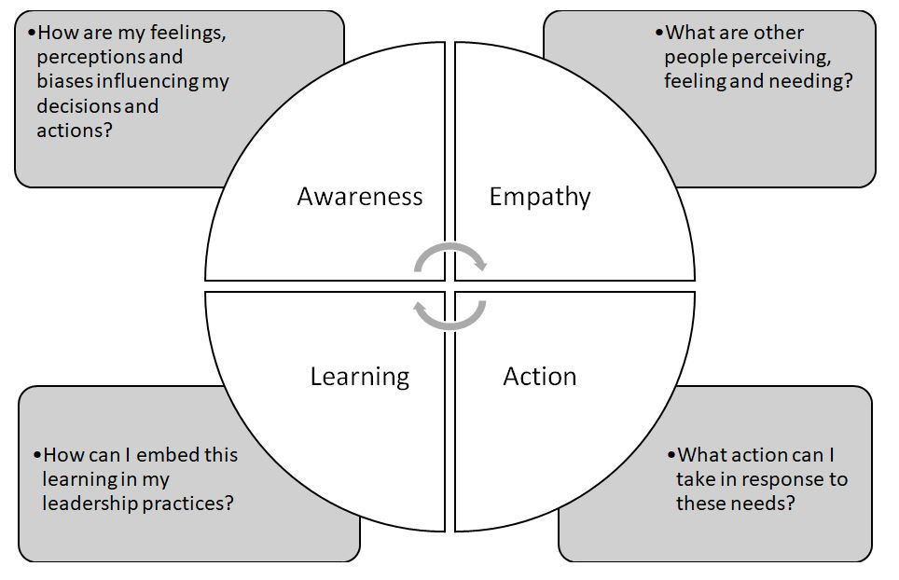

https://www.tvwleadershipacademy.nhs.uk/inclusion/inclusion

