James Scouller's Three Levels of Leadership model
Scouller uses a four-square overlapping diagram (adapted below) to present leadership as a four-dimensional process.
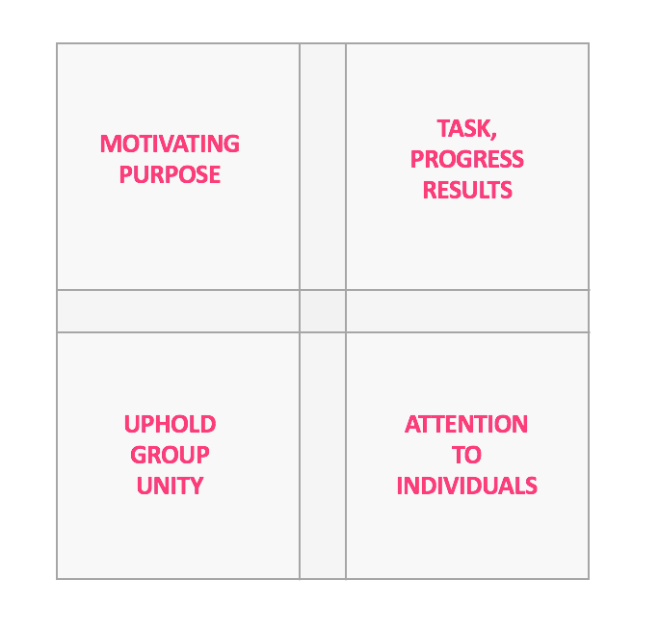
Scouller - leadership as a four-dimensional process

Four Dimensions
James Scouller says:
"Leadership is a process that involves:
- Setting a purpose and direction which inspires people to combine and work towards willingly;
- Paying attention to the means, pace and quality of progress towards the aim; and
- Upholding group unity, and
- Attending to individual effectiveness throughout."
(From The Three Levels of Leadership, J Scouller, 2011)
Scouller's four-square model above can be seen as an extension of John Adair's Action-Centred Leadership three-circles concept.
Note that Scouller describes leadership as a process. By that, he means "...a series of choices and actions around defining and achieving a goal."
Scouller says that if you see leadership as a process you are less likely to make the mistake of seeing 'leadership' and the 'leader' as one and the same.
Scouller and other authors like John Adair point out that leadership does not have to rely on one person.
Scouller's explains further, "...we can say that anyone in a group could lead a group in one of the four leadership dimensions, which clearly suggests the possibility of shared leadership..."
This raises the question that if anyone can lead, does a group actually need a formal leader? Scouller says 'yes', and defines the leader's purpose as follows:
"The purpose of a leader is to make sure there is leadership - to ensure that all four dimensions of leadership are being addressed... This means the leader does not always have to lead from the front; he or she can delegate, or share part of their responsibility for leadership. However, the buck still stops with the leader. So although the leader can let someone else lead in a particular situation, he or she cannot let go of responsibility to make sure there is leadership."
Scouller offers the example: "The leader has to ensure there is a vision or a goal that all (or at least most) group members want to deliver, but that doesn't mean he or she has to come up with the vision on their own. That is one way of leading, but it's not the only way. Another way is to co-create the vision with one's colleagues."
Scouller has firm views about shared and delegated leadership, subject to the principle - crucially - that ultimate responsibility is retained by the leader.

3P Model
Scouller's Three Levels of Leadership model is also referred to as the 3P model.
The three Ps stand for Public, Private and Personal leadership.
Scouller sees two aims for his model:
- To help leaders understand what they have to do in their role.
- To help leaders understand how to develop themselves so they can behave powerfully, skilfully and flexibly while staying true to character - being authentic - (for useful reference see the authentic leadership philosophy).
Here is the diagram for Scouller's Three Levels of Leadership (3P) model:
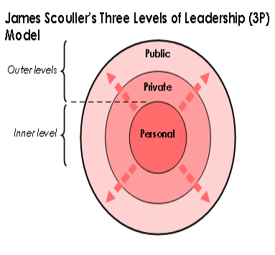
The Three Levels of Leadership model builds on Scouller's idea that the leader must ensure there is leadership in all four dimensions:
- Motivating future or purpose
- Task and results
- Upholding group spirit and standards
- Attention to individuals (for example, motivation, confidence, selection, feelings of inclusion)
Scouller's main idea is that for leaders to be effective in all four dimensions, they must work on three levels simultaneously:
- Public Leadership: an outer or behavioural level. It covers dimensions 1, 2 and 3 (Purpose, Task, Group Unity).
- Private Leadership: another outer or behavioural level. It covers dimensions 2 and 4 (individual aspects of Task, attention to Individuals).
- Personal Leadership: an inner level. It covers all four dimensions (Purpose, Task, Group Unity, Individuals), although less directly than the two outer levels.
Scouller explains that 'Personal Leadership' affects all four dimensions by working on the sources of a leader's effectiveness: their leadership presence, technical know-how, skill, attitude to other people, and psychological self-mastery.
Self-mastery, according to Scouller's Three Levels model, is the key to a person's leadership presence, to his/her attitude toward others, and flexibility. Scouller argues that Personal Leadership is the most influential of the three levels because positive change at the personal level has positive 'ripple' effects at the two outer levels. The same is also true in reverse.
Notice that the four dimensions represent a functional view of leadership that we see in other models. However, the integration of the four dimensions (functions) with the 'three levels' of leadership seems unique to Scouller's model and in this respect can be considered highly innovative, and probably an advance in established thinking about leadership models.

Summary
Here is a more detailed summary of Scouller's Three Levels of Leadership:
Scouller's Three Levels Of Leadership (3P) Model - summary of details
Public Leadership | Private Leadership | Personal Leadership
The 'Public Leadership' level involves a leader's actions in a group setting (for example, a meeting) or when trying to influence an organization as a whole.  Includes setting the vision, ensuring unity of purpose, achieving the group task, building an atmosphere of trust and togetherness and creating peer pressure towards shared, high-performance standards.  There are 34 Public Leadership behaviours across two areas:  - 22 Group Purpose and Task  - 12 Group Building and Maintenance  The 22 Group Purpose and Task behaviours set the group's aims and get the job done. They divide into four sub-groups:  - Setting the vision, staying focused (4 behaviours)  - Organising, giving power to others (2 behaviours)  - Ideation, problem-solving, decision-making (10 behaviours)  - Executing (6 behaviours)  The 12 Group Building and Maintenance behaviours create and uphold a group identity and atmosphere of shared responsibility for overall performance. There are two sub-groups of behaviours:  - Leader out in front (5 behaviours)  - Leader in among the group (7 behaviours)  Leaders need to balance their attention to purpose/task and building/maintenance.  Some leaders over-emphasise the former and ignore the need to create a team spirit. Others are more concerned with atmosphere and pay insufficient attention to results. | 'Private Leadership' is the leader's one-to-one handling of group members.  It recognises that although team spirit is essential, everyone is an individual with differing levels of confidence, resilience, experience and motivation.  Individuals need individual attention as well as group bonding.  There are 14 private leadership behaviours across two categories:  - 5 Individual Purpose and Task  - 9 Individual Building and Maintenance  There are 5 Individual Purpose and Task behaviours: appraising, selecting, disciplining, goal-setting, and reviewing.  The 9 Individual Building and Maintenance behaviours are for growing and upholding each individual's 'know-how', skills and confidence. They include getting to know colleagues as individuals and building relationships, attracting new talent, and assessing people's competence and commitment.  As in Public Leadership, leaders need to balance their attention to both areas to avoid missing important aspects of individuals' effectiveness. | The 'Personal Leadership' level is the most influential of the three levels. It refers to leaders' technical, psychological and moral growth and its effect on their leadership presence, know-how, skill and behaviour. It drives a leader's emotional intelligence, personal impact, skill, judgement, and insight in action. (US-English, judgment)  Scouller says, "Personal Leadership is the key to what Jim Collins called 'the inner development of a person to level 5 leadership' in his book Good to Great."  Personal Leadership has three elements:  - Technical  - Attitude Towards Others  - Self-Mastery  - Technical: knowing your technical weaknesses and continually updating your knowledge and skills. It involves:  - Learning time management and the basics of individual and group psychology.  - Practising the six skill sets that support the public and private behaviours. They are: (1) group problem solving and planning; (2) group decision-making; (3) interpersonal ability; (4) managing group process; (5) assertiveness; (6) goal-setting.  - Attitude towards others: this is about believing other people to be as important as you - or learning to believe it. This is important because your attitude towards others will largely decide how much they trust you as a leader. It involves developing the five characteristics of an effective attitude (interdependence, appreciation, caring, service, balance) by creating a compelling shared vision and by practising self-mastery.  - Self-Mastery: this is working on self-awareness and flexible command of your psyche, enabling you to let go of limiting beliefs and old habits, connect with your values, let your leadership presence flow and act authentically in the service of those you lead. It involves:  - Understanding the principles of and obstacles to personal change.  - Practising self-mastery techniques, drawing on modern psychology and neuroscientific research.

Scouller's Integrated Approach
Scouller's Three Levels of Leadership (3P) model seeks to use the strengths of traditional and earlier leadership theories, while also while addressing the leader's psychology - notably the problem of limiting beliefs - and the question of leadership presence and authenticity.
Scouller's model is therefore aptly called 'integrated'.
The model incorporates and in some cases extends what Scouller considers to be the most useful aspects of prior theories, alongside Scouller's own new and original thinking about leadership psychology, by which he aims to produce a model that is a step beyond previous concepts.
Scouller's integrated approach makes use of four types of leadership models:
- Trait theory
- Behavioural ideals theory
- Situational/Contingency theory
- Functional theory
Here are the main details of how Scouller's 3P model integrates and extends the four types of previous theories:

Integration of Existing Leadership Models
How Scouller's 3P Leadership Model integrates and extends previous leadership models theory
Traits theory | Scouller agrees that the best leaders have a certain distinctive quality (often referred to as 'leadership presence'). However, unlike the Traits theory approach, the 3P model says that 'leadership presence' cannot be defined by common pre-determined qualities or behavioural characteristics. Indeed Scouller argues that these common traits - which supposedly guarantee leadership success - don't exist, which is why, he suggests, researchers have found so many leadership traits. Instead, the Three Levels model says leaders should let their distinctive presence flow according to their individual personality, so expressing their unique combination of character strengths to best effect. Scouller says leaders can develop their presence through self-mastery.
Behavioural Ideals theory | Scouller's 3P model accepts the Behavioural Ideals view that a leader should usually combine a high concern for task with equal concern for people. However, it goes further in showing leaders how to work on their psychology so they can adopt this attitude if it doesn't come naturally to them. Scouller also argues that the true behavioural ideal is not one fixed style of behaviour because leaders can and should flex their approach according to the circumstances (for example, being more 'task-focused' in emergencies) while staying true to their values.
Situational/ Contingency theory | Scouller's 3P model supports the Situational/Contingency idea of flexing leadership behaviour to match the follower(s) or circumstances. But it recognises that many leaders get caught in certain mindsets (beliefs) and behavioural habits and find it hard to change their behaviour - even if they have had training and know in theory that it is a good idea to do so. The 3P model shows how leaders with inflexible habits can change their beliefs and behaviour while remaining 'authentic'. Scouller says the solution is to remove inner psychological blocks (limiting beliefs) by practising self-mastery.
Functional theory | Like the Functional models, Scouller's 3P model describes what leaders must do by listing key leadership behaviours. However, it goes further by explaining the know-how and skills underlying the behaviours and how to learn them. It also addresses the psychology of leaders and explains how self-mastery can help them develop their leadership presence and stop limiting beliefs blocking the use of their skills.

James Scouller's Three Levels model also overlaps with three of the leadership philosophies, which are described in the next section: Servant Leadership, Authentic Leadership and Values-based Leadership.
This is because the 'inner level' - Personal Leadership - of Scouller's 3P model includes what Scouller calls self-mastery.
Scouller asserts that "...self-mastery is the key to developing not only leadership presence and your attitude towards others, but also letting you connect with your values, allowing the authentic 'you' to flow, thus enabling you to be an effective servant-leader..."
Scouller reinforces the connection between his Three Levels model and the three leadership philosophies mentioned above in asserting that, "...true leadership presence is synonymous with authenticity, expressing one's highest values and an attitude of service."

Acknowledgements

James Scouller Biography
I am grateful to James Scouller for his help, patience, and expert contribution in producing this leadership guide.
James Scouller is an expert coach and partner at The Scouller Partnership in the UK, which specialises in coaching leaders. He was chief executive of three international companies for eleven years before becoming a professional coach in 2004. He holds two postgraduate coaching qualifications and trained in applied psychology at the Institute of Psychosynthesis in London.
James Scouller's book is called "The Three Levels of Leadership: How to Develop Your Leadership Presence, Know-how and Skill". It was published in May 2011. I commend it to you, and his thinking too.
You can learn more about James Scouller's book at three-levels-of-leadership.com.
Details of James Scouller's executive coaching work are at TheScoullerPartnership.co.uk.

