# 

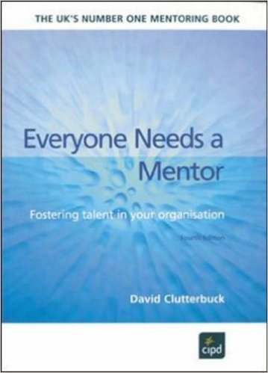 **“Everybody Needs a Mentor”** – David Clutterbuck

# http://ecx.images-amazon.com/images/I/51fcKxOIXdL._SX382_BO1,204,203,200_.jpg *“*Techniques for Coaching and Mentoring” - David Megginson and David Clutterbuck

# 

**“S.U.M.O. – Shut up Move on”** – Paul McGee

[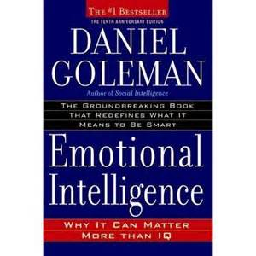](https://uk.images.search.yahoo.com/images/view;_ylt=A2KLj.oyhSlU6mMA0xVNBQx.;_ylu=X3oDMTIyZ2lrcDN2BHNlYwNzcgRzbGsDaW1nBG9pZAM4MzM0OWVmYzU5NmJiZTIyNDhmODYyZWEyZTIyYjVmNQRncG9zAzEEaXQDYmluZw--?back=https://uk.images.search.yahoo.com/search/images?p=emotional+intelligence+goleman+book&fr=yfp-t-903-s&fr2=piv-web&tab=organic&ri=1&w=450&h=450&imgurl=media-cache-ak0.pinimg.com/736x/fe/00/74/fe0074a6edc4efa5e7dd69c847a12f78.jpg&rurl=http://www.pinterest.com/pin/116601077826253073/&size=31.9KB&name=%3cb%3eEmotional%3c/b%3e+%3cb%3eIntelligence%3c/b%3e+/+Daniel+%3cb%3eGoleman%3c/b%3e&p=emotional+intelligence+goleman+book&oid=83349efc596bbe2248f862ea2e22b5f5&fr2=piv-web&fr=yfp-t-903-s&tt=%3cb%3eEmotional%3c/b%3e+%3cb%3eIntelligence%3c/b%3e+/+Daniel+%3cb%3eGoleman%3c/b%3e&b=0&ni=21&no=1&ts=&tab=organic&sigr=11gdf6i92&sigb=142he2sbn&sigi=12da8u9jk&sigt=11sem0id8&sign=11sem0id8&.crumb=J603USF4DaT&fr=yfp-t-903-s&fr2=piv-web)

**“Emotional Intelligence”** – Daniel Goleman

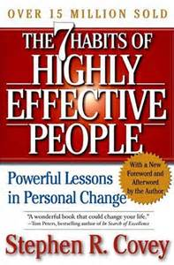

**“The 7 habits of highly effective people”** – Stephen Covey

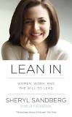

**“Lean in: Women, Work, and the Will to Lead”**

* Sheryl Sandburg

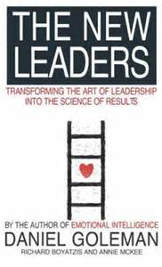

**“The New Leaders: turning the art of leadership into the**

**science of results”** – Daniel Goleman, Richard Boyatzis,

Annie McKee

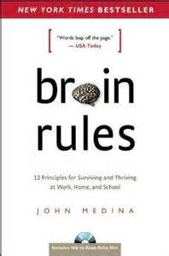

**“Brain rules: 12 principles for surviving and thriving at**

**work, home and school”** – John Medina

[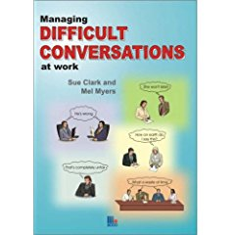](http://www.amazon.co.uk/gp/product/images/1852525401/sr=8-2/qid=1265802740/ref=dp_image_0?ie=UTF8&n=266239&s=books&qid=1265802740&sr=8-2)

**“Difficult conversations at work”** – Sue Clark and Mel Myers



**“Feel the fear and do it anyway”** – Susan Jeffers



**“I’m OK – you’re OK”** – Thomas A. Harris M.D.

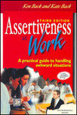

**“Assertiveness at work”** – Ken Back and Kate Back

[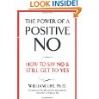](http://www.amazon.co.uk/Power-Positive-No-William-Ury/dp/0340923806/ref=sr_1_1?s=books&ie=UTF8&qid=1321273781&sr=1-1)

**“The Power of a positive NO”** – William Ury

[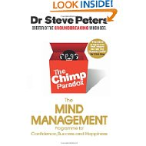](http://www.amazon.co.uk/Chimp-Paradox-Management-Confidence-ebook/dp/B006K26BEQ/ref=sr_1_1?ie=UTF8&qid=1381744347&sr=8-1&keywords=the+chimp+paradox)

**“The Chimp Paradox”** – Dr.Steve Peters

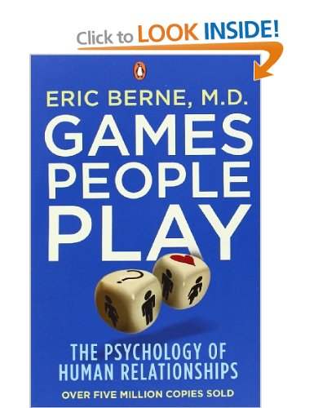

**“Games people play”** – Eric Berne

[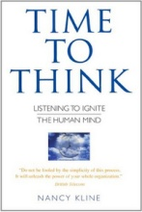](http://r.search.yahoo.com/_ylt=A2KLj9KVJylUOlYAsrFWBQx.;_ylu=X3oDMTBtaTBhcHJnBHNlYwNmcC1pbWcEc2xrA2ltZwRpdAM-/RV=2/RE=1412012053/RO=11/RU=http:/www.kerrycullen.com/resources/RK=0/RS=7Dp5mQfNaIuBnRPLOaO36G4HZQc-)

**“Time to Think”** – Nancy Kline

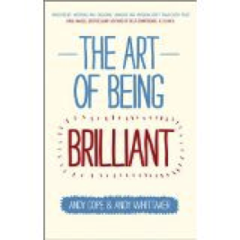

**“The Art of being brilliant: transform your life by doing what**

**works for you”** – Andy Cope and Andy Whittaker