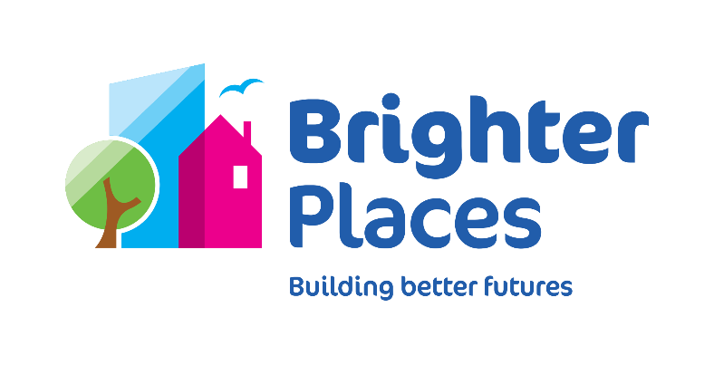

**Role profile**

**The purpose of this document is to give a high-level description of the role, to enable you to have a reasonable understanding of what are the main activities and objectives. In addition, the person specification indicates the skills and experience that you will need to be successful in this role.**

|  |  |  |  |
| --- | --- | --- | --- |
| **Job Title:** | Damp and Mould Surveyor | | |
| **Directorate:** | Homes | **Department:** | Investment |
| **Reports to:** | Investment Manager | | |
| **Line management responsibility:** | None | | |
| **Budgetary responsibility:** | No | | |
| **Prepared by:** | Homes Director | | |
| **Date:** | April 24 | | |

**Overall Directorate purpose:**

**Deliver Brighter Places ‘Great Homes and Partnerships Strategy’**, underpinned by a commitment to a **Great Customer Experience**.

* Delivery will be through our Growth & Partnerships, Asset management, Decarbonisation and Repairs strategies, maximising the quality of our new and existing homes, engaging with customers to listen to and meet their hopes and needs.
* Asset Management will meet our customer promises, ensure our residents are safe, warm and comfortable in their homes. We will fully understand our homes based on good quality data and provide the highest quality homes we can.
* We will ensure our homes meet and exceed all property health, safety and compliance standards protecting our customers and our reputation as a landlord.
* We will deliver our Decarbonisation reducing the environmental impact of our homes and embracing new and innovative technology and solutions for new and existing homes.
* We will deliver our Growth & Partnerships Strategy, identifying and evaluating opportunities for development, and considering a wider spectrum of investment opportunities and related risks.
* We will identify and deliver new business and partnerships to support the development of superb new homes that contribute towards the sustainability of our communities and achieve our growth targets.
* We will put customers first; engage with, listen to and positively respond to our customers

**Overall purpose of the role:**

The key responsibility of the Damp and Mould Surveyor is to provide a high-quality customer-focused and professional repairs service to provide technical solutions and support on complex repairs and maintenance issues related to damp condensation, and mould (D&M) including monitoring of works/services where required, in accordance with Health & Safety policies and statutory obligations.

**EDI Accountabilities:**

* Actively take accountability to make sure all Colleagues and residents feel included. Challenge your decisions – “am I being inclusive”
* Challenge poor behaviour of others and promote best practice.
* Participate and support in the implementation of the EDI strategy and improvement programmes.
* Listen to, value, and respond to the views and ideas of others and appreciate differences in cultures, backgrounds, needs, and choices. Ensure you treat all people equitably, taking into consideration difference, and with dignity and respect.

**Key working relationships:**

|  |  |
| --- | --- |
| **Who?** | **How?** |
| Internally | |
| Line manager | Keep fully informed and escalate as appropriate |
| Homes Directorate and other Brighter Places departments | Full collaboration and open communication |
| Externally | |
| Our customers | Listen to customers’ needs and ensure that communication about works and projects is clear |
| Contractors and suppliers | Ensure that requirements and standards are clear and fulfilled |
| Other agencies, e.g. utilities companies etc. | Clear, open, and timely information about works |

**Key role responsibilities**:

* Provide a high quality customer focused service to all residents, leaseholders, other stakeholders and colleagues.
* Support and monitor contractor’s delivery of D&M solutions. Liaise with contractors to agree works, raise orders, and carry out pre/post work inspections
* Work closely with the Coordinators to manage live jobs, arranging workflows with repair partners and keeping customers fully updated.
* Provide input into D&M cases and disrepair claims. Carry out disrepair surveys and produce professional analysis, cost, predictions and report to support work being done and the protection of Brighter Places from spurious or exaggerated claims
* Monitor progress of D&M and disrepair cases and ensure that appropriate remedial works are in place within an appropriate timescale to avoid dissatisfied customers and escalation of disrepair
* Supporting the responsive repairs team and major works team whilst looking for positive solutions to reported D&M case.
* Accurately diagnose, specify, order, supervise and manage technical D&M solutions whilst considering all repairs needed.
* Produce reports outlining structural and/or repair based solutions to treat D&M.
* Provide accurate analysis and specification of works, raising orders for remedial works, preparing variations and ensuring completion to approved timescales within budget and ensure value for money.
* Supporting relevant teams with D&M inspections to ensure properties are safe and warm before being let to customers.
* Requesting customer decants when required due to the Health and Safety risks ensuring all necessary paperwork is completed.
* Support our Asset team that carry out stock condition surveys and HHSRS assessments to ensure all D&M is recorded accurately ensure an agreed programme of properties & upload these into Asset Pro as and when required.
* Respond to queries from tenants, leaseholders, internal and external clients within prescribed time scales.
* Provide input into any required KPI’s, ensuring that all targets are met and performance is of a high standard
* Support the Customer Services and Housing teams in answering technical queries and inspections regarding the construction, handover and defects management of properties.
* Effectively use Microsoft packages, IT systems and databases as necessary to deliver work.
* Ensure relevant legislation and guidance is followed in the delivery of building work including CDM, Health & Safety at Work Act, Building and Planning Regulations.
* Support the organization to comply with the Homes England service standards, following and comply with all relevant policies, procedures and standing orders.
* Provide excellent customer services always and learn and improve services from any customer feedback, satisfaction and complaints through a continuous improvement mindset and approach

**Responsibilities for us all:**

* Work with all our colleagues, customers and stakeholders in a collaborative and supportive way that reflects our Values.
* Demonstrate a commitment to value for money and high-quality customer service in all that we do.
* Be an ambassador for the organisation, representing Brighter Places in a positive manner and creating a positive impression with all internal colleagues and all external customers and stakeholders.
* Contribute to Brighter Places being a diverse and inclusive organisation.
* Act at all times within laid down guidance and requirements in our Rules, Policies, Procedures, Standing Orders and Financial Regulations, the Code of Conduct and Colleague Handbook.
* Participate in learning and development activities that develop personal effectiveness and assist in improving performance in the role and in your team.
* Be flexible to change within the organisation when necessary and provide assistance, if required. Undertaking any other duties as may reasonably be required in line with the level of responsibility of the post and in order to meet the changing needs of the organisation.

**No role profile can be entirely comprehensive, and the post holder will be expected to carry out such activities that are required and are broadly consistent with the above role profile. Role profiles are subject to continuous review and will be updated on an ongoing basis subject to management discretion. Significant changes to the role will be discussed with job holders.**

**Person Specification**

|  |  |  |
| --- | --- | --- |
|  | **Essential Requirements** | **Desirable Requirements** |
| **Education & qualifications** | 1. HNC, HND, BTEC HND or higher, in a building discipline or relevant experience and training. | 1. Degree level qualification |
| **Experience, knowledge &  understanding** | 1. Track record of delivering excellent customer service, even whilst working under pressure. 2. Demonstrable experience of working in reactive maintenance, diagnosing & ordering reactive repairs 3. Experienced Surveyor within DC&M Inspections 4. Understanding of housing and property customer service 5. Able to write high quality documentation and reports. 6. Excellent knowledge of building and housing regulations and legislation 7. Knowledge and understanding of landlords’ statutory repair, maintenance and health and safety responsibilities including fire risk 8. Knowledge of schedule of rates contracts | 1. Social Housing experience |
| **Skills & abilities** | * Ability to communicate clearly and accurately with a wide range of internal and external customers. * Positive and self-motivated. * Ability to prioritise, plan and manage a busy workload. * Ability to thoroughly and consistently inspect and assess standards, with an eye for detail to identify variation from defined standards. * Ability to multi-task in a reactive environment. * Excellent IT skills – good working knowledge of Microsoft Office applications and Housing Management systems. * Excellent written and oral communication skills. * Can work effectively with and support colleagues to help achieve team objectives. * Aptitude for innovation and creativity to aid continual service improvement. * Excellent influencing and communication skills * Act with integrity and accountability. * Analytical, numerate ability to identify trends and isolate issues from KPI data |  |
| **Behaviours** | * Positive and assertive. * Committed to resolving issues. * Positive attitude to continuous improvement. * Ability to work on own initiative, but also be a team player, willing to adopt a confident approach. |  |
| **Other** | * Valid UK Driving License. * Ability to travel independently to visit sites, properties etc. |  |