**Inclusive Leadership Programme**

**Proposal:**

To deliver a programme focused on developing great leaders and role models for diversity in Sport Wales. Through this the Leadership Team will:

* Apply a people centred inclusive leadership approach.
* Lead a shared vision for diversity across Sport Wales.
* A strong, cohesive leadership team

This programme will include all those on the Leadership Team. The programme will consist of 5 half day sessions spread over 18 months.

These outcomes contribute to Sport Wales successfully embedding equality (SW framework for embedding equality).

**Context:**

The need for this programme has been identified in the following areas:

Strategic Equality Plan

The internal aim of the Sport Wales strategic equality plan is to create a culture in Sport Wales that recognises and responds to individual needs (equality objective 11).

People Strategy

Implement a Strategic Equality Plan that represents high performance (ref 5.3)

Investors in People

Raise emotional intelligence amongst Leaders, as identified in the Investors in People outcome report - *‘The Board and Directors are keen to focus on people first, to raise emotional intelligence…’*

Equality Standard Recommendations

* Continue to develop staff engagement and understanding of equality so that it becomes embedded into the culture of the organisation
* Inclusion of equality behaviours into performance reviews
* Ensuring that the outcomes from EqIA’s are communicated regularly to all staff
* Enabling feedback from EqIA’s completed by Calls to Action projects and other funded programmes to be communicated internally and to help shape future investment decisions
* Increasing the diversity of the workforce at all levels of the organisation
* Working collaboratively with external partners, including NGB’s, to address underrepresentation within the workforces
* Continuing to address the diversity of the Board
* Considering what and how to increase the diversity of performance coaches and support staff
* Ensuring that the diversity of elite athletes addresses underrepresentation and that role models are identified and promoted
* Ensuring that NGB’s, as possibly Sport Wales biggest ally, and clearly informed in relation to Sport Wales positive action schemes, so that they too can contribute to achieving greater diversity across all sport. This needs to be

**Content**:

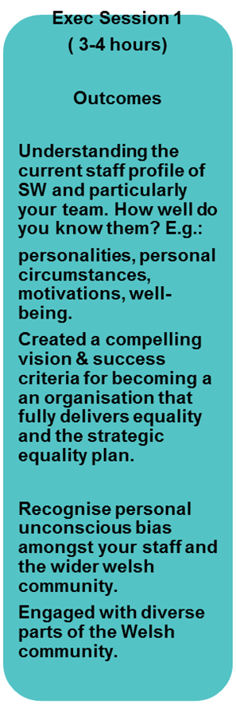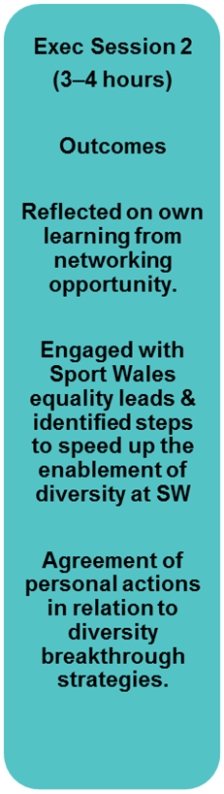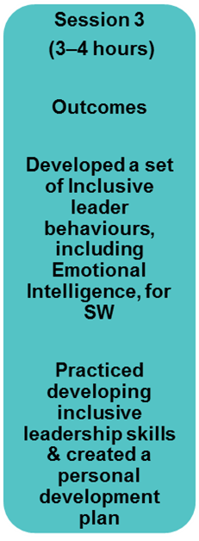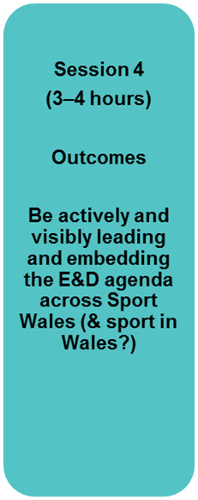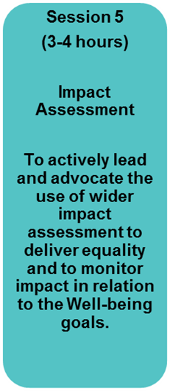

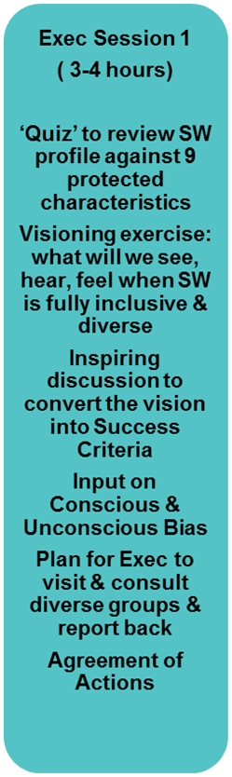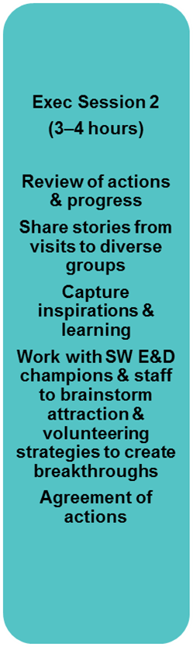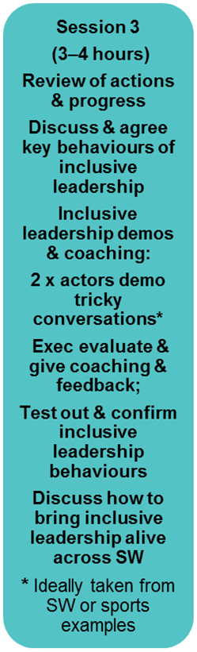

**Cost:**

|  |  |
| --- | --- |
| Consultation with Exec members & sponsors & design of 4 interventions | £2,000.00 |
| Facilitation of 4 interventions | £4,000.00 |
| Actors from RolePlays for Training | £2,000.00 |
| Possible collaboration with | £500.00 |
| Impact Assessment session | £500.00 |
| **Total Cost** | **£9,000** |

**Success Measures:**

As a result of this programme the following improvements will be evidenced through the annual equality report:

* Leadership Team completing required equality information on board papers.
* Keep the Equality Impact Assessment Log up to date (in business plan).
* Equality Impact assessments completed on plans, strategies, policies and decisions.
* Up to date equality training needs analysis for all staff.
* Staff and board diversity.

Leadership team self-assessed behaviour performance indicators before and after training programme:

|  |  |  |
| --- | --- | --- |
| **Statement** | **Have done / are confident to do** | **Target** |
| I have discussed and shared with my team the main focus and key themes of the Sport Wales Strategic Equality Plan. | 30% |  |
| I have conducted and I am confident in conducting Equality Impact Assessment which conforms to the Sport Wales template. | 20% |  |
| I understand and can explain how the Strategic Equality Plan relates to Sport Wales Strategies. | 50% |  |
| I have a clear understanding of the relationship between the Business Plan and the Equality Action Plan and have ensured that officers understand this when preparing their individual work programmes and report progress. | 50% |  |
| In my role supporting the development, delivery and reviewing of a policy I would naturally want to understand how those who share a protected characteristics have been engaged with and understood by consulting and engaging with under-represented groups. | 10% |  |
| When I have tendered or procured goods or services I have given due regard to equality and diversity when appointing. | 20% |  |
| Have you appropriately managed a situation where equality has impacted on the well-being of an individual? | 50% |  |
| I ensure that the skills and behaviours of staff in relation to equality are developed and would discuss this as part of the performance review and staff development. | 40% |  |
| When considering my own personal development I have considered my skills and behaviours in relation to equality. | 50% |  |
| I have felt comfortable listening to a member of staff discussing a personal issue in relation to equality. | 50% |  |
| I have felt confident in the approach that I have taken to supporting a member of staff who has disclosed a personal equality issue to me. | 40% |  |

Staff survey data measures will increase as a result of the programme:

|  |  |  |  |
| --- | --- | --- | --- |
| **Staff Survey Index** | **2015** | **2016** | **Target** |
| Inclusiveness | 5.48 | 5.70 |  |
| Wellbeing | 5.08 | 5.27 |  |
| Personal Growth | 5.30 | 5.34 |  |
| Motivation | 5.76 | 5.92 |  |
| My Manager | 5.71 | 5.79 |  |