Job Description
Job title: | Team Leader | Location: | Merseyside
Responsible for: | Sheltered Housing Coordinator, Scheme Manager and Cleaners | Responsible to: | Senior Older Person Services

Overview of the role
To support the Senior Older Person Services Manager in service delivery.
To deliver services/demands alongside Contracts and Local Authorities.
To provide comprehensive Supported Housing Management services to customers.
To develop, deliver and monitor customer focused services.
To support a culture of continuous improvement and customer service.
To provide leadership and management of staff.
To work with colleagues and external partners to deliver joined up services to customers.
To deliver value for money services for our customers.
To provide and ensure compliance is adhered to monitored.
To provide all statistical information and to produce reports as required.

Main responsibilities and accountabilities
Leadership and Management
- To provide leadership and management to staff and to embed Plus Dane’s vision, values and organisational culture.
- To be responsible for the management, supervision, development and training of the Supported Housing Team including supervision and regular 121`s to effectively monitor performance and ensure that outcomes and standards are being achieved to an excellent standard.
- To advise the Senior Older Person Services Manager immediately of any breaches in safeguarding policy and any other action/incident that has a detrimental impact on our residents or services.
- Oversee/ Manage the Staff in the referral of residents to appropriate external support agencies where residents have been identified as requiring support and assistance to enable them to live independently.

- To develop and support effective team relationships.
- To support the continuous learning of team members
- To contribute to the development and successful implementation of strategies, policies, procedures and practices.
- To be accountable for performance and achievement of targets, goals and objectives within the designated team.
- To be accountable for the management of the team budget.
- To ensure all of Plus Dane’s assets and resources are used effectively and delivered in line with the “Value for Money” strategy.
Efficient Running of services
- To drive sustained team performance.
- To be accountable for adequate staff cover at all times.
- To oversee and work with internal and external teams regarding tenancy breaches and action appropriately
- To oversee and manage person centred assessments ensuring customers receive appropriate support and assistance.
- Ensure accurate and thorough information is maintained for each customer. Resident Support
- To promote a customer and performance focused culture.
- To support vulnerable people to recognise and accept responsibility for their own decisions and make informed choices.
- To support residents to identify move-on/alternative accommodation and support those in securing appropriate accommodation.
- Ensure/oversee comprehensive induction for all new customers.
- Take necessary and prompt action if clients do not comply with the terms and conditions of their tenancy agreements.
- To be accountable for ensuring that residents receive appropriate advice and guidance to maximise their income and access appropriate benefits.
- To encourage and promote customer participation at all levels of service delivery.
- To work with vulnerable people to maintain and develop positive relationships with the local community.
- To identify advise and assist with incidents of nuisance and anti-social behaviour and to take action as appropriate.
- To actively promote equal opportunities and challenge prejudice and discrimination.
- To be accountable for the maintenance of all records required of service delivery.
- To manage and oversee the team with managing risk.
Other Duties
- To assist in the development of policies and procedures and good working practice and contribute to the continuous improvement of the service.
- To consult with and develop positive partnerships with all relevant statutory and voluntary agencies.
- To oversee rent control and recovery of arrears and maximisation of benefits for residents, in liaison with the Income Maximisation Team.
- To oversee the selection, referral and allocation of customers where and when required.
- To help develop and co-ordinate the induction process for new customers and staff.
- To attend relevant training courses, supervisions and team briefings as required.
- To embrace diversity and take a proactive approach in ensuring that the Company’s Equal Opportunities Policy and Equality and Diversity Strategy and Action Plan are implemented at all times.
- To provide a high standard of service to clients at all times as required by Plus Dane Housing’s Customer Service Policy and Service Standards.
- To work at all times within the requirements of Dane Housing’s Code of Conduct for Employees and other corporate policies and procedures.
- To abide by the Company’s Health & Safety Policy and Procedures at all times.
- To liaise effectively and appropriately with colleagues to ensure the smooth running of the scheme and the effective management of the tenancies.
- Ensure the prompt reporting of repairs and monitor completions in line with Plus Dane procedures.
- Any other duties as may reasonably be expected of the post holder.

Key contacts
The post is responsible for actively promoting and representing Plus Dane to a broad range of stakeholders. Key contacts in the post are detailed below.
Key internal contacts are:  - Support Services Manager  - Income Maximisation Team  - Welfare Benefits Teams  - Customer Services  - Anti-Social Behaviour Team | Key external contacts are:  - Customers  - Mainstay  - Local Authority  - Social Services  - Police etc.

Person Specification
Job title: | Team Leader

Area | Requirements
Education | - Qualifications demonstrating sound literacy and numeracy skills (e.g. GCSE English & Maths A-C equivalent) (D)  - Training relevant to the role e.g. First Aid, Health and Safety, Scheme Safety and Security checks,) (D)  - Is familiar with the use of IT systems (D)  - Can demonstrate the ability to write clear and concise letters and reports (D)  - Holds a full driving license and has use of a car (E)
Experience & knowledge | - Demonstrates an excellent understanding of the operating environment for supported housing services. (E)  - Experience of working with vulnerable people. (E)  - Demonstrates knowledge experience of Safeguarding. (E)  - Able to work using own initiative, as well as part of a cohesive team. (E)  - Able to communicate effectively with customers, colleagues and professional agencies. (E)  - Ability to closely follow procedure – e.g. emergency procedures, fire safety. (E)  - Computer literate. (E)  - Keen understanding of GDPR and confidentiality requirements. (E)  - Excellent administration skills. (E)  - Excellent problem solving skills. (E)  - Able to work well under pressure. (E)  - Encourages and supports the team to deliver outstanding service to customers and communities. (E)  - Encourages and supports the team to work with confidence, resilience and integrity. (E)  - Able to deliver personal targets and objectives. (E)  - Experience of staff supervision (E)
Personal qualities | - Delivers personal targets and objectives.  - Ability to work without direct supervision.  - Uses a variety of skills & techniques to communicate with others.  - Uses a variety of skills & techniques to communicate with others.  - Willingness to work flexibly to meet the needs of the service.  - A positive and responsive attitude to change; participating and contributing to improvements and solutions.  - Works collaboratively with others, generating a positive team dynamic, building effective working relationships.  - Sensitive and supportive person centred approach to customers, particularly those with complex needs.  - Demonstrate Plus Dane values of Learn & Grow, Achieve for our Customers, Working Together, Take Ownership  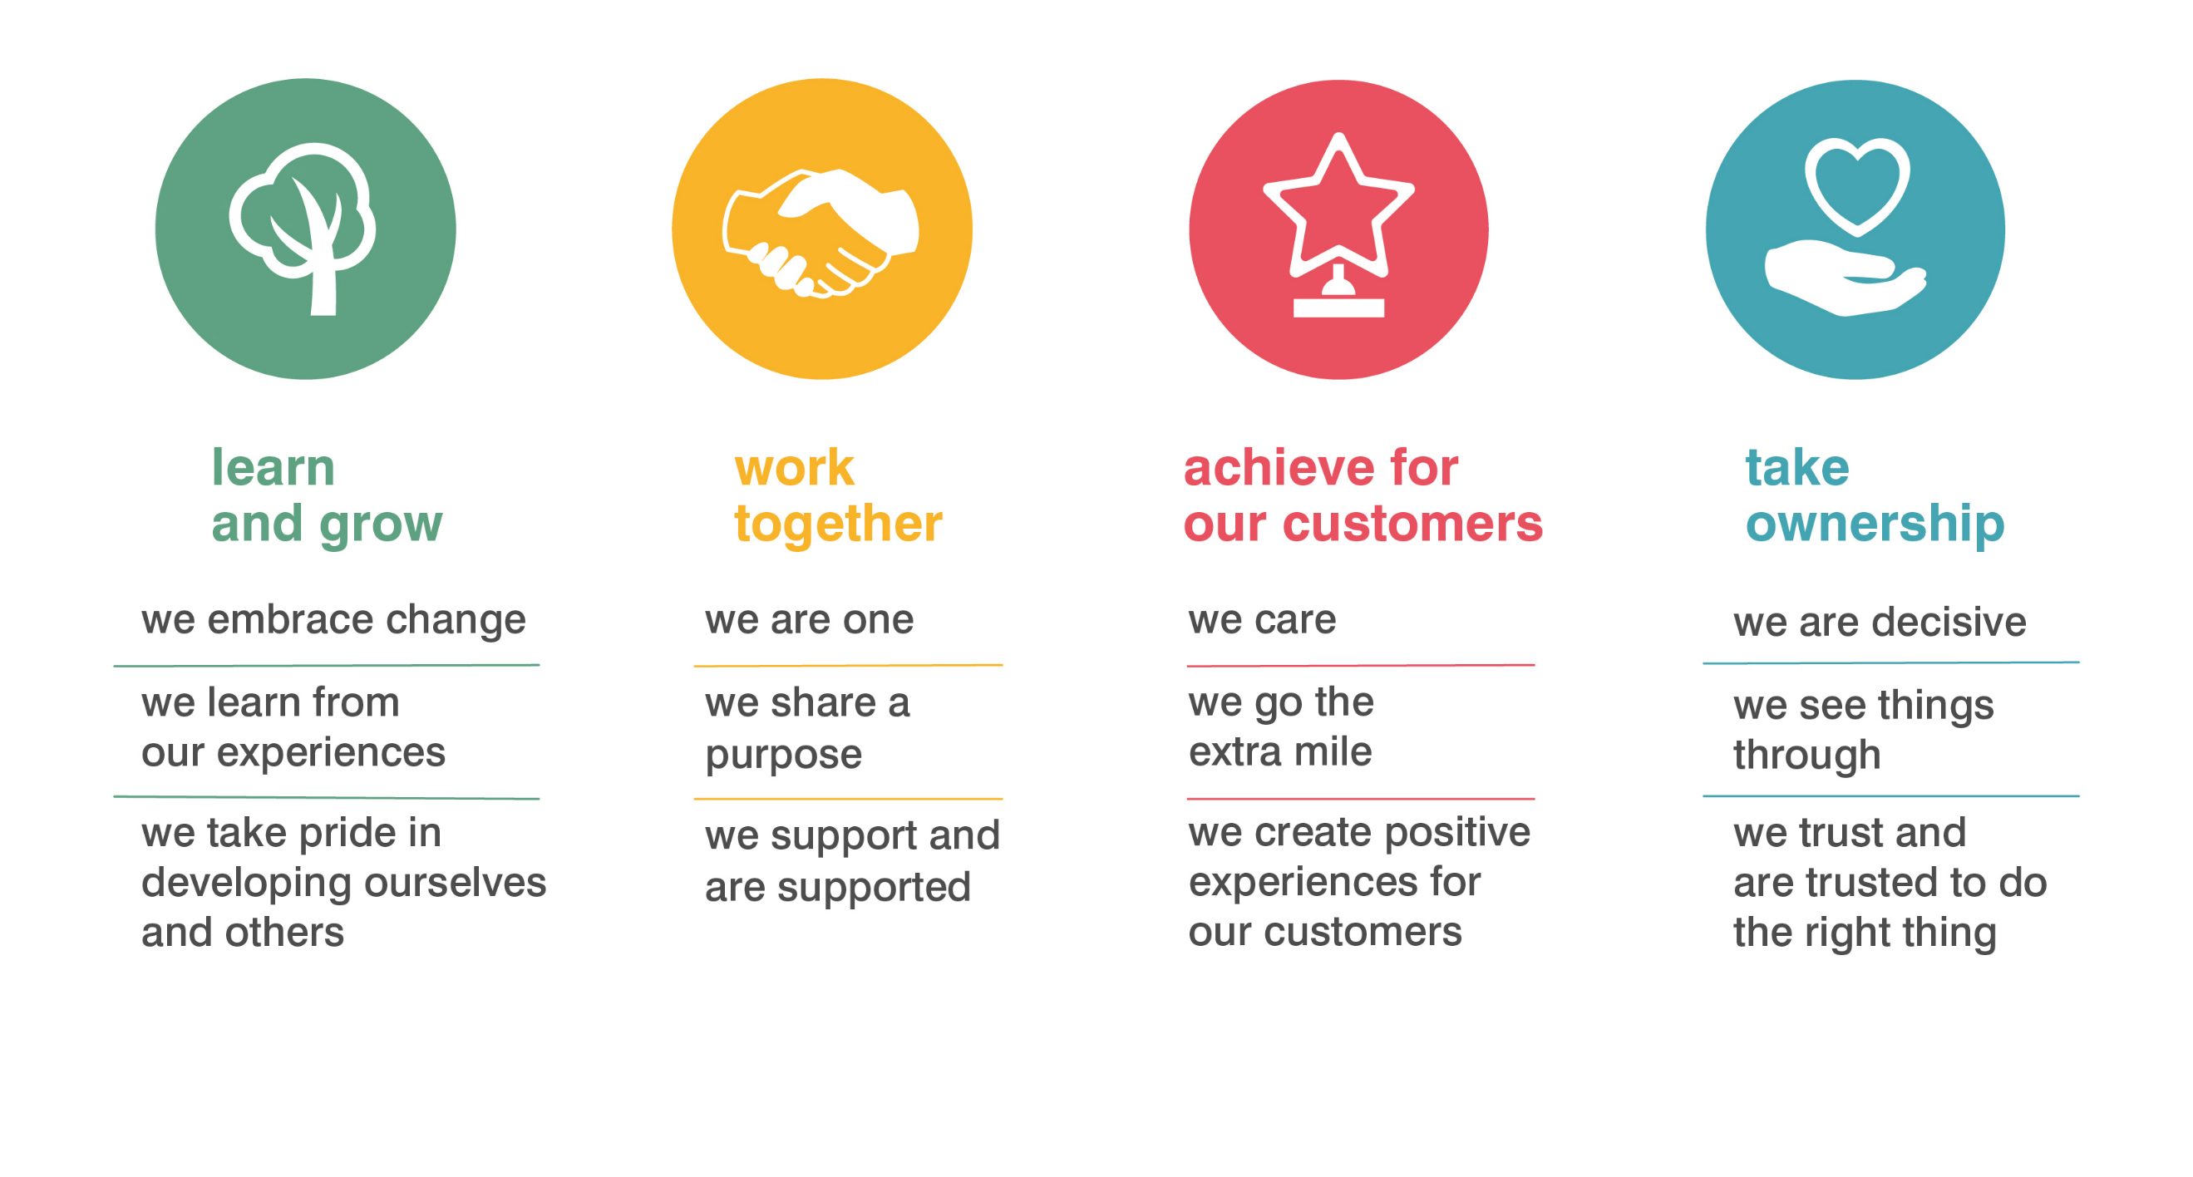

Plus Dane Housing is committed to safeguarding and promoting the welfare of young people and vulnerable adults and expects all staff and volunteers to share this commitment.

